**Types of software development life cycles methodologies:**

1. **Waterfall Model**
2. **V- Model**
3. **Iterative Model**
4. **Agile Methodology**

**1.Waterfall Model:** It is a very straightforward approach: finish one phase, then move on to the nest. No going back. Each stage relies on information from the previous stage and has its own project plan. [ Linear and sequential model].

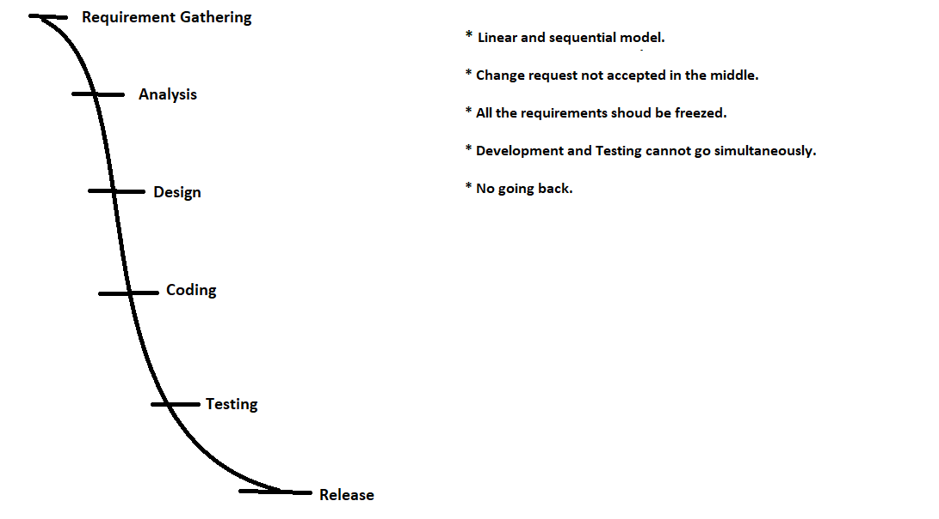

**2. V – Model:** is extension of Waterfall model, Verification and Validation. Development and Testing go simultaneously.

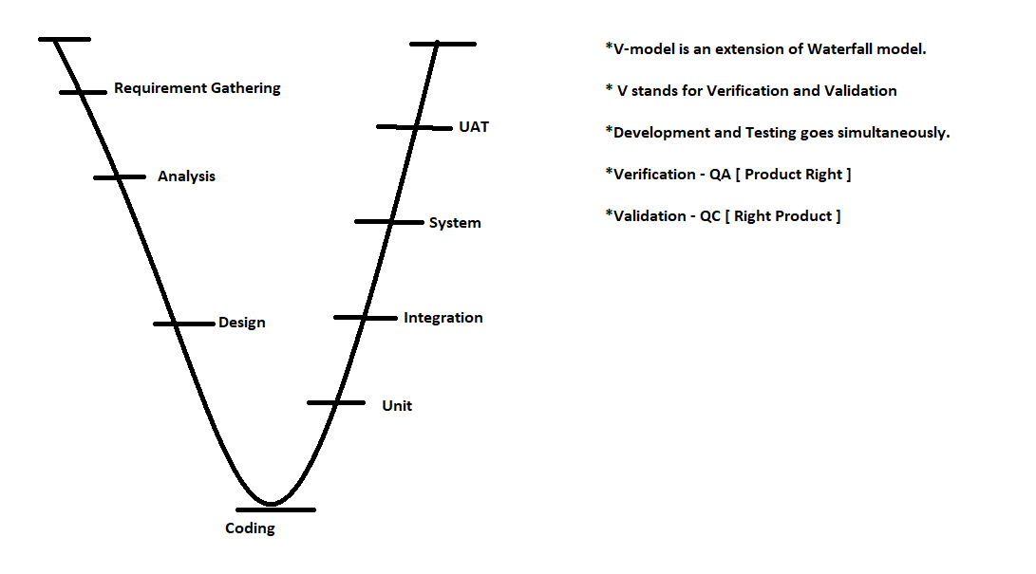

**3. Iteration Model:** is to split into small parts and add to on another. Instead of starting with fully known requirements, project team implement a set of software requirements, then test, evaluate and pinpoint further requirements.

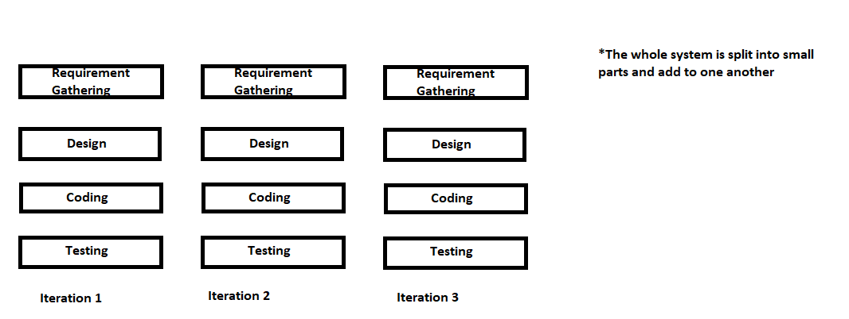

**4. Agile:** is not a model it is a methodology.it is a major driving force behind software development in many organizations. In Agile, “fast failure” is good thing. The approach produces ongoing release cycles, each featuring small, incremental changes from the previous release. At each iteration, the product is tested. The Agile model helps teams identify and address small issues on projects before they evolve into more significant problems and engage business stakeholders and get their feedback throughout the development process.

In Agile methodology, many teams are also applying an Agile framework as **Scrum** to help structure more complex development projects. Scrum teams work in “**Sprints**” which usually last two to four weeks. More communication less documentation. Flexible and transparent.

**Agile Meeting**: **Character is Agile**

Sprint planning meeting Scrum Master

Daily stand up BA

Backlog grooming PO

Showcase meeting Agile Developer team

Retrospective meeting. Agile Testing team

